ML Project Results

Patient Exclusion Summary
Total patients: 533
Excluded due to missing death information: 7
Included in survival analysis: 526
Excluded from binary model (censored <12 months, outcome unknown): 72
Included in binary models: 454

Summary Table: Age at Diagnosis and OS Months
Variable | Mean | Median | Min | Max | Missing (n) | Missing (%)
age_at_diagnosis | 58.75 | 62.0 | 18.0 | 88.0 | 0 | 0.0
os_months | 19.17 | 10.01 | 0.03 | 102.87 | 0 | 0.0

Gene Mutation Summary Table
Gene | Positive (n) | Positive (%) | Negative (n) | Negative (%) | Missing (n) | Missing (%)
flt3_itd_cat | 121 | 23.0 | 405 | 77.0 | 0 | 0.0
npm1_cat | 145 | 27.57 | 381 | 72.43 | 0 | 0.0
runx1_cat | 64 | 12.17 | 462 | 87.83 | 0 | 0.0
asxl1_cat | 54 | 10.27 | 472 | 89.73 | 0 | 0.0
tp53_cat | 53 | 10.08 | 473 | 89.92 | 0 | 0.0

Sex Summary Table
Sex | Count | Percent
male | 290 | 55.13
female | 236 | 44.87
missing | 0 | 0.0
total | 526 | 100.0

Denovo Category Summary Table
denovo_cat | Count | Percent
true | 186 | 35.36
false | 339 | 64.45
missing | 1 | 0.19
total | 526 | 100.0

ELN 2017 Classification Summary Table
ELN class | Count | Percent
favorable | 173 | 32.89
intermediate | 121 | 23.0
adverse | 217 | 41.25
missing | 15 | 2.85
total | 526 | 100.0

Chromosome Category Summary Table
chromosome cat | Count | Percent
normal | 155 | 29.47
complex | 326 | 61.98
missing | 45 | 8.56
total | 526 | 100.0

Survival Models Harrell's C-index Comparison and AUROC at 12 months
Model | Mean C-index ± SD | Avg AUROC
Cox (ELN2017 classification) | 0.576 ± 0.027 | 0.666
Penalized Cox (ElasticNet) | 0.642 ± 0.023 | 0.774
Random Survival Forest | 0.708 ± 0.023 | 0.781
Gradient Boosted Survival (GBM) | 0.709 ± 0.023 | 0.778

Binary Models Performance (AUROCs and Brier scores)
Model | CV AUROC Mean | CV AUROC Std | CV Brier Mean | CV Brier Std
Logistic Regression | 0.764 | 0.049 | 0.199 | 0.02
RandomForest | 0.701 | 0.052 | 0.241 | 0.029
XGBoost | 0.684 | 0.054 | 0.292 | 0.041
MLP | 0.686 | 0.057 | 0.273 | 0.039

Model Hazard Ratios for each variables
Variable | Cox_HR | Cox_HR_CI_lower | Cox_HR_CI_upper | Logistic_OR | Logistic_OR_CI_lower | Logistic_OR_CI_upper
age_at_diagnosis | 1.0311 | 1.0214 | 1.0408 | 2.105 | 1.5922 | 2.7829
eln2017mode | 1.2506 | 1.0518 | 1.4869 | 1.8048 | 1.2237 | 2.6618
sex_male | 1.1915 | 0.9265 | 1.5322 | 1.5845 | 0.9733 | 2.5794
chromosome_cat_normal | 1.0 | 0.9995 | 1.0005 | 0.9358 | 0.5334 | 1.6418
denovo_cat_true | 1.1319 | 0.8743 | 1.4653 | 1.361 | 0.8086 | 2.2908
flt3_itd_cat_positive | 1.0 | 0.9985 | 1.0015 | 1.2785 | 0.6799 | 2.4041
npm1_cat_positive | 1.0977 | 0.7831 | 1.5388 | 1.3478 | 0.6552 | 2.7724
runx1_cat_positive | 1.0 | 0.9993 | 1.0007 | 1.0299 | 0.4844 | 2.1899
asxl1_cat_positive | 1.0 | 0.9992 | 1.0008 | 0.816 | 0.3577 | 1.8615
tp53_cat_positive | 1.9362 | 1.3142 | 2.8526 | 2.938 | 1.1579 | 7.4544

Model Importance Scores for each variable
Variable | XGB | GBM | MLP
age_at_diagnosis | 0.09700000286102295 | 0.6012 | 0.3661
eln2017mode | 0.1956000030040741 | 0.1286 | 0.3055
sex_male | 0.08049999922513962 | 0.0437 | 0.2671
chromosome_cat_normal | 0.08760000020265579 | 0.0099 | 0.2639
denovo_cat_true | 0.08980000019073486 | 0.0519 | 0.2925
flt3_itd_cat_positive | 0.12139999866485596 | 0.008 | 0.2887
npm1_cat_positive | 0.07349999994039536 | 0.0409 | 0.3531
runx1_cat_positive | 0.07150000333786011 | 0.0038 | 0.2918
asxl1_cat_positive | 0.06889999657869339 | 0.0111 | 0.3712
tp53_cat_positive | 0.11410000175237656 | 0.1008 | 0.3439

Robustness Analysis: 1000 Bootstrap 95% CIs
Metric | Mean | 95% CI Lower | 95% CI Upper
Cox_age_at_diagnosis | 1.027 | 1.019 | 1.035
Logistic_age_at_diagnosis | 2.142 | 1.68 | 2.75
RF_age_at_diagnosis | 0.536 | 0.491 | 0.578
XGB_age_at_diagnosis | 0.097 | 0.071 | 0.127
GBM_age_at_diagnosis | 0.532 | 0.424 | 0.63
Cox_eln2017mode | 1.272 | 1.111 | 1.447
Logistic_eln2017mode | 1.822 | 1.339 | 2.502
RF_eln2017mode | 0.129 | 0.092 | 0.171
XGB_eln2017mode | 0.183 | 0.087 | 0.289
GBM_eln2017mode | 0.16 | 0.079 | 0.27
Cox_sex_male | 1.145 | 1.0 | 1.392
Logistic_sex_male | 1.197 | 0.958 | 1.485
RF_sex_male | 0.051 | 0.043 | 0.061
XGB_sex_male | 0.077 | 0.051 | 0.111
GBM_sex_male | 0.04 | 0.01 | 0.082
Cox_chromosome_cat_normal | 1.01 | 1.0 | 1.11
Logistic_chromosome_cat_normal | 0.989 | 0.765 | 1.243
RF_chromosome_cat_normal | 0.048 | 0.039 | 0.059
XGB_chromosome_cat_normal | 0.091 | 0.057 | 0.132
GBM_chromosome_cat_normal | 0.024 | 0.004 | 0.053
Cox_denovo_cat_true | 1.154 | 1.0 | 1.41
Logistic_denovo_cat_true | 1.233 | 0.962 | 1.557
RF_denovo_cat_true | 0.056 | 0.044 | 0.073
XGB_denovo_cat_true | 0.09 | 0.057 | 0.13
GBM_denovo_cat_true | 0.05 | 0.017 | 0.099
Cox_flt3_itd_cat_positive | 1.031 | 1.0 | 1.231
Logistic_flt3_itd_cat_positive | 1.142 | 0.894 | 1.461
RF_flt3_itd_cat_positive | 0.046 | 0.035 | 0.059
XGB_flt3_itd_cat_positive | 0.095 | 0.054 | 0.153
GBM_flt3_itd_cat_positive | 0.024 | 0.004 | 0.059
Cox_npm1_cat_positive | 1.034 | 1.0 | 1.239
Logistic_npm1_cat_positive | 1.212 | 0.919 | 1.611
RF_npm1_cat_positive | 0.031 | 0.024 | 0.041
XGB_npm1_cat_positive | 0.068 | 0.037 | 0.113
GBM_npm1_cat_positive | 0.041 | 0.01 | 0.083
Cox_runx1_cat_positive | 1.003 | 0.961 | 1.101
Logistic_runx1_cat_positive | 0.955 | 0.757 | 1.206
RF_runx1_cat_positive | 0.029 | 0.021 | 0.037
XGB_runx1_cat_positive | 0.066 | 0.034 | 0.11
GBM_runx1_cat_positive | 0.012 | 0.001 | 0.035
Cox_asxl1_cat_positive | 1.019 | 1.0 | 1.186
Logistic_asxl1_cat_positive | 1.023 | 0.795 | 1.285
RF_asxl1_cat_positive | 0.029 | 0.02 | 0.04
XGB_asxl1_cat_positive | 0.082 | 0.043 | 0.146
GBM_asxl1_cat_positive | 0.014 | 0.001 | 0.039
Cox_tp53_cat_positive | 2.0 | 1.532 | 2.597
Logistic_tp53_cat_positive | 1.545 | 1.162 | 2.102
RF_tp53_cat_positive | 0.045 | 0.025 | 0.071
XGB_tp53_cat_positive | 0.151 | 0.059 | 0.315
GBM_tp53_cat_positive | 0.102 | 0.054 | 0.168
Cindex_Cox | 0.713 | 0.685 | 0.741
Cindex_RSF | 0.844 | 0.828 | 0.859
Cindex_GBM | 0.799 | 0.777 | 0.823
AUROC_Logistic | 0.797 | 0.759 | 0.834
AUROC_RF | 0.999 | 0.998 | 1.0
AUROC_XGB | 0.999 | 0.998 | 1.0

Bootstrap Summary: C-index (Cox / RSF / GBM)
Metric | Mean | 95% CI Lower | 95% CI Upper
Cindex_Cox | 0.713 | 0.685 | 0.741
Cindex_RSF | 0.844 | 0.828 | 0.859
Cindex_GBM | 0.799 | 0.777 | 0.823

Bootstrap Summary: AUROC (Logistic / RF / XGB)
Metric | Mean | 95% CI Lower | 95% CI Upper
AUROC_Logistic | 0.797 | 0.759 | 0.834
AUROC_RF | 0.999 | 0.998 | 1.0
AUROC_XGB | 0.999 | 0.998 | 1.0

Time-dependent AUROC for Cox, RSF, GBM survival
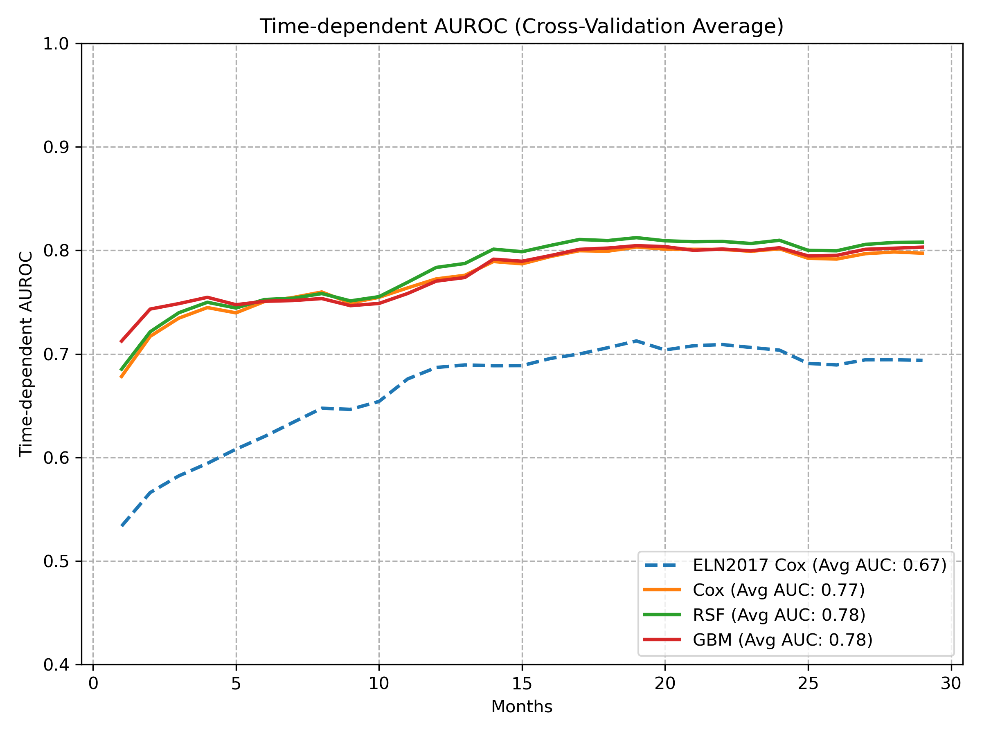

ROC Curves for Binary Models (Logistic Regression, Random Forest, XGBoost, MLP)
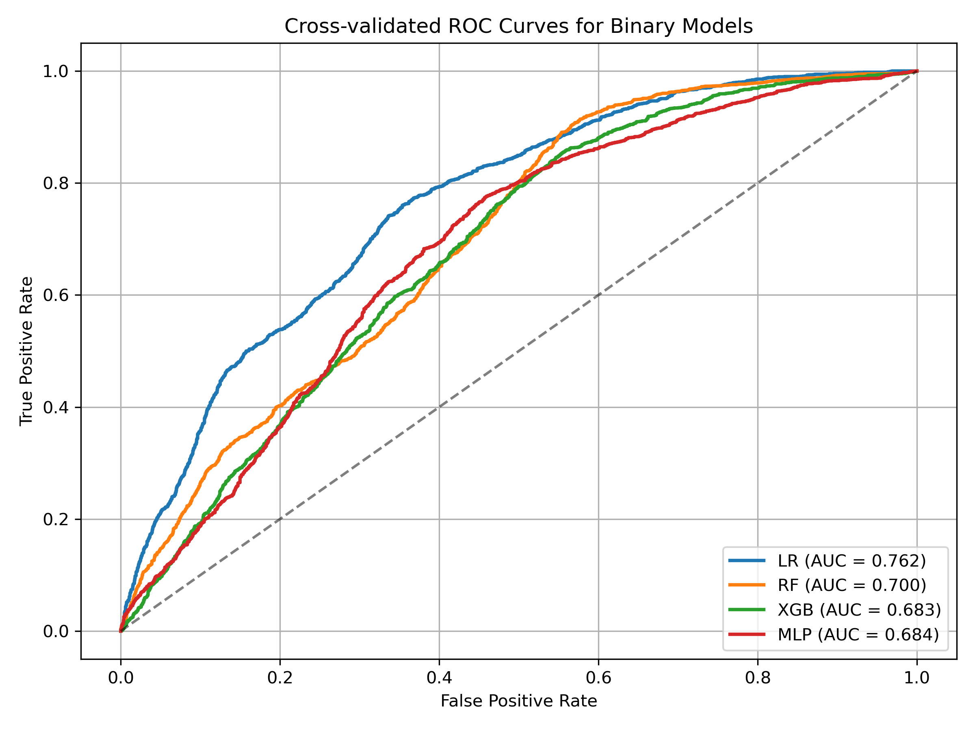

Calibration Plots for Binary Models (Logistic Regression, Random Forest, XGBoost, MLP)
